LAB MID

DESIGN PATTERNS

NAME: ASIM TARIQ

REG.NO: FA20-BSE-037

CLASS DIAGRAM:

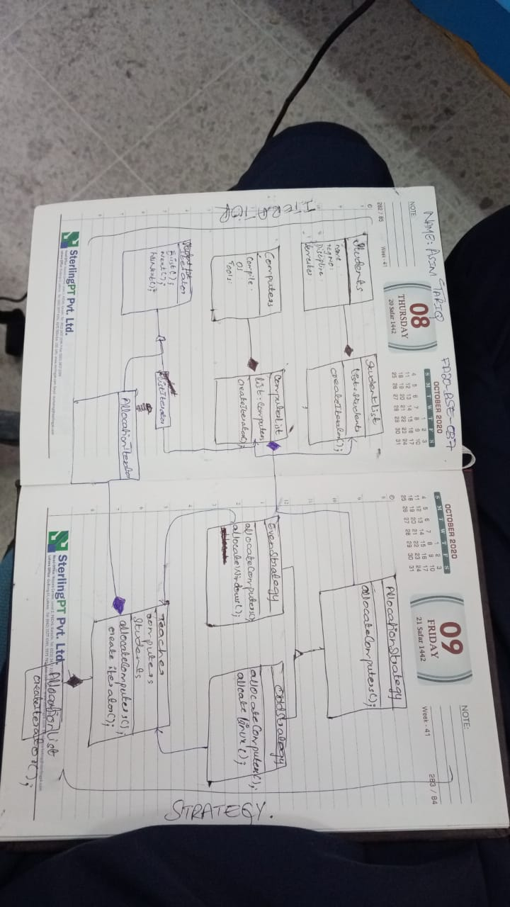\

CODE:

public class Main {

public static void main(String[] args) {

// Instantiate a Classroom

Classroom classroom = new Classroom();

// Add computers to the classroom

classroom.addComputer("C001", "Linux", "Eclipse");

classroom.addComputer("C002", "Windows", "Visual Studio");

classroom.addComputer("C003", "Linux", "NetBeans");

// Add students to the classroom

classroom.addStudent("John Doe", "S001", 3);

classroom.addStudent("Jane Smith", "S002", 4);

classroom.addStudent("Bob Johnson", "S003", 2);

// Allocate computers using a specific strategy (Linux in this case)

classroom.allocateComputers(new LinuxStudentAllocationStrategy());

// Create an iterator and iterate over the allocation list

AllocationIterator iterator = classroom.createIterator();

while (iterator.hasNext()) {

Object currentItem = iterator.next();

if (currentItem instanceof Student) {

Student student = (Student) currentItem;

System.out.println("Student: " + student.getName() + " - Computer: "

+ student.getAllocatedComputer().getCNumber());

} else if (currentItem instanceof Computer) {

Computer computer = (Computer) currentItem;

System.out.println("Computer: " + computer.getCNumber() + " - Allocated to: "

+ (computer.getAllocatedStudent() != null ? computer.getAllocatedStudent().getName() : "None"));

}

}

}

}

/\*

\* Click nbfs://nbhost/SystemFileSystem/Templates/Licenses/license-default.txt to change this license

\* Click nbfs://nbhost/SystemFileSystem/Templates/Classes/Class.java to edit this template

\*/

package midterm;

/\*\*

\*

\* @author LAPTOP HOUSE

\*/

public class MIDTerm {

public static void main(String[] args) {

// Instantiate a Classroom

Teacher classroom = new Classroom();

// Add computers to the classroom

classroom.addComputer("C001", "Linux", "Eclipse");

classroom.addComputer("C002", "Windows", "Visual Studio");

classroom.addComputer("C003", "Linux", "NetBeans");

// Add students to the classroom

classroom.addStudent("John Doe", "S001", 3);

classroom.addStudent("Jane Smith", "S002", 4);

classroom.addStudent("Bob Johnson", "S003", 2);

// Allocate computers using a specific strategy (Linux in this case)

classroom.allocateComputers(new OddStrategy());

// Create an iterator and iterate over the allocation list

AllocationIterator iterator = classroom.createIterator();

while (iterator.hasNext()) {

Object currentItem = iterator.next();

if (currentItem instanceof Student) {

Student student = (Student) currentItem;

System.out.println("Student: " + student.getName() + " - Computer: "

+ student.getAllocatedComputer().getCNumber());

} else if (currentItem instanceof Computers) {

computer = (Computers) currentItem;

System.out.println("Computer: " + computer.getCNumber() + " - Allocated to: "

+ (computer.getAllocatedStudent() != null ? computer.getAllocatedStudent().getName() : "None"));

}

}

}

}